Count number of beneficiaries each state:

|  |  |  |
| --- | --- | --- |
| **1** | AK | 84412 |
| **2** | AL | 196896 |
| **3** | AR | 84790 |
| **4** | AZ | 350032 |
| **5** | DE | 15928 |
| **6** | FL | 1702472 |
| **7** | GA | 472012 |
| **8** | HI | 1518 |
| **9** | IA | 170610 |
| **10** | ID | 69442 |
| **11** | IL | 432827 |
| **12** | IN | 677393 |
| **13** | KS | 113504 |
| **14** | LA | 172060 |
| **15** | ME | 72752 |
| **16** | MI | 1023190 |
| **17** | MO | 148948 |
| **18** | MS | 42482 |
| **19** | MT | 148632 |
| **20** | NC | 365684 |
| **21** | ND | 104408 |
| **22** | NE | 80902 |
| **23** | NH | 18176 |
| **24** | NJ | 173175 |
| **25** | NM | 37832 |
| **26** | NV | 32016 |
| **27** | OH | 884530 |
| **28** | OK | 186472 |
| **29** | OR | 68402 |
| **30** | PA | 475022 |
| **31** | SC | 1563770 |
| **32** | SD | 76000 |
| **33** | TN | 155994 |
| **34** | TX | 859714 |
| **35** | UT | 85398 |
| **36** | VA | 325316 |
| **37** | WI | 1013278 |
| **38** | WV | 162322 |
| **39** | WY | 46134 |

calculate median insurance cost/person each state:

|  |  |  |
| --- | --- | --- |
| **1** | AK | 577.0000 |
| **2** | AL | 190.0800 |
| **3** | AR | 131.3400 |
| **4** | AZ | 316.9800 |
| **5** | DE | 341.1350 |
| **6** | FL | 219.8200 |
| **7** | GA | 232.0700 |
| **8** | HI | 243.1050 |
| **9** | IA | 296.9750 |
| **10** | ID | 297.7300 |
| **11** | IL | 337.9200 |
| **12** | IN | 322.8500 |
| **13** | KS | 225.2700 |
| **14** | LA | 324.9900 |
| **15** | ME | 322.9400 |
| **16** | MI | 45.4700 |
| **17** | MO | 33.0000 |
| **18** | MS | 258.0150 |
| **19** | MT | 278.9900 |
| **20** | NC | 45.3300 |
| **21** | ND | 320.4000 |
| **22** | NE | 221.4400 |
| **23** | NH | 314.6350 |
| **24** | NJ | 427.6500 |
| **25** | NM | 242.4800 |
| **26** | NV | 278.1173 |
| **27** | OH | 232.1500 |
| **28** | OK | 302.6800 |
| **29** | OR | 260.0000 |
| **30** | PA | 304.6500 |
| **31** | SC | 340.7000 |
| **32** | SD | 345.7800 |
| **33** | TN | 271.3000 |
| **34** | TX | 150.2850 |
| **35** | UT | 261.1700 |
| **36** | VA | 246.4300 |
| **37** | WI | 424.4600 |
| **38** | WV | 315.4300 |
| **39** | WY | 404.2850 |

Calculate mean rate for each state:

|  |  |  |
| --- | --- | --- |
| **1** | AK | 7024.9347 |
| **2** | AL | 12131.7384 |
| **3** | AR | 15069.1980 |
| **4** | AZ | 3976.5038 |
| **5** | DE | 359.1234 |
| **6** | FL | 311.2058 |
| **7** | GA | 6427.4337 |
| **8** | HI | 256.3415 |
| **9** | IA | 319.6395 |
| **10** | ID | 18457.3768 |
| **11** | IL | 372.4453 |
| **12** | IN | 4855.9185 |
| **13** | KS | 11346.7586 |
| **14** | LA | 8716.8499 |
| **15** | ME | 355.5592 |
| **16** | MI | 3052.6029 |
| **17** | MO | 12305.7333 |
| **18** | MS | 12977.0197 |
| **19** | MT | 5133.9766 |
| **20** | NC | 8206.3581 |
| **21** | ND | 7218.9284 |
| **22** | NE | 9155.7209 |
| **23** | NH | 351.4295 |
| **24** | NJ | 422.0172 |
| **25** | NM | 12148.5742 |
| **26** | NV | 299.1220 |
| **27** | OH | 3743.6986 |
| **28** | OK | 5157.5781 |
| **29** | OR | 277.1509 |
| **30** | PA | 3746.2842 |
| **31** | SC | 5681.3398 |
| **32** | SD | 9836.8662 |
| **33** | TN | 9608.4668 |
| **34** | TX | 5709.2828 |
| **35** | UT | 6710.9200 |
| **36** | VA | 319.3265 |
| **37** | WI | 477.0377 |
| **38** | WV | 347.9025 |
| **39** | WY | 12103.5946 |

plot on map by state :

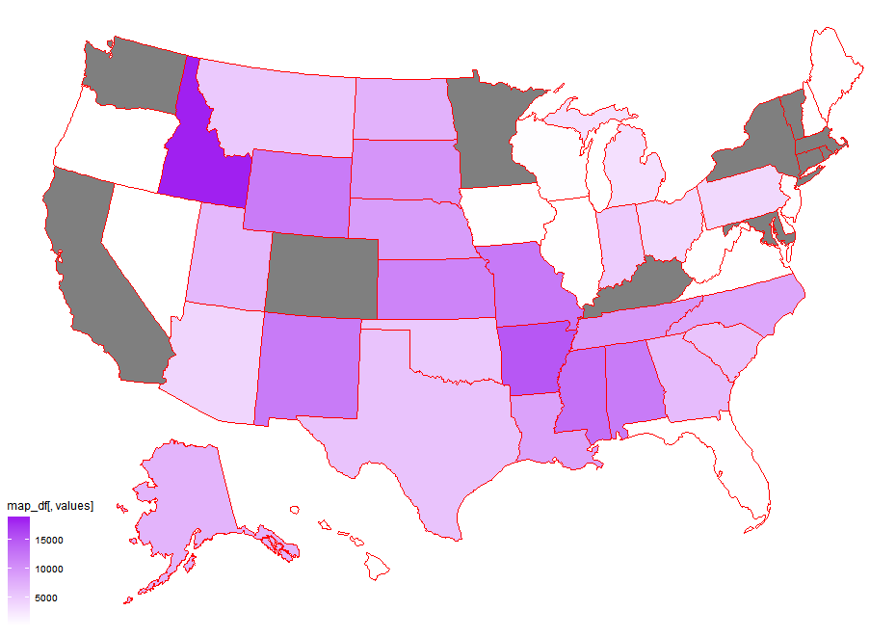

Why some states are missing:

Because the Rate.csv doesn’t have their data at the first place.

Compare with cancer ：

Seems that the higher the cancer rate is, the lower the mean individual-rate will be in the state.

Compare with stroke :

Seems that the higher the stroke mortality is, the lower the mean individual-rate will be in the state.